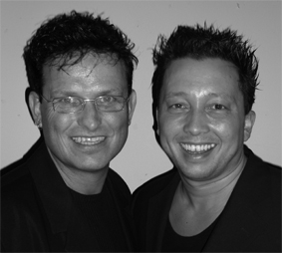
Bleeding Love

Choreografers : Roy Verdonk and Wil Bos
Level : Intermediate
Dance : 4 wall

Counts : 32 counts
Music : Bleeding love – Leona Lewis
Intro : 32 counts after first beat (appr. 21 sec.)
Note : Tag & Restart after wall three

Right Press Forward, Recover, ½ Turn Right (x3), Step, ¼ Turn, Cross Shuffle
1-2 Press right forward, Recover
3&4 ½ Turn right Step right forward, ½ right step left back, ½ turn right step right forward 6:00
5-6 Step left forward, ¼ turn right 9:00
7&8 Cross left over right, Step right to right side, Cross left over right

Option: 3&4 - ¼ Turn right step right to right side, Close left next to right, ¼ Turn right step right forward

&Cross, Unwind, &Step, &1/4 Turn, Cross, Touch Out, Touch In, Step, Weave
&1 Step right to right side, Cross left toe behind right
2-3 Unwind ¾ turn left (weight stays on right) 12:00
&4 Close left next to right, Step right forward
&5 ¼ Turn left, Cross right over left 09:00
6&7 Toucht left to left side, Touch left next to right, Step left to left side
8&1 Cross right behind left, Step left to left side, Cross right over left

Sway, Sway, Cross, ¼ Turn, Step Back (x3), Cross
2-3 Sway hips to the left, Sway hips to the right
4&5 Cross left over right, ¼ Turn left Step right back, Step back on left 06:00
6-7-8 Step back on right, Step back on left, Cross right over left

½ Turn (x2), Rock, Recover, Front Sailor Step ¼ turn, Rock, Recover, ½ Turn
  - ½ Turn left step left forward, ½ Turn left step back on right (sweep left from front to back)
3&4 Cross left behind right, Recover on right, Step left to left diagonal
5&6 Cross right over left, ¼ Turn right step left back, Step right to right side 09:00
7&8 Rock left forward, Recover, ½ Turn left step left forward 03:00

Tag after wall three: Tag and Restart

Right Press Forward, Recover, ½ Turn Right (x3), Step, 1/2 Turn, Left Shuffle
1-2 Press right forward, Recover
3&4 ½ Turn right Step right forward, ½ right step left back, ½ turn right step right forward
5-6 Step left forward, 1/2 turn right
7&8 Step forward on left, Close right beside left, Step forward on left.

Restart after the tag

Start again and let the music touch your soul

